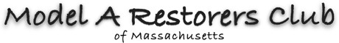
MEMBERSHIP FORM

Name: Date:

Spouse/Significant Other:

Street Address:

City/Town: State: ZIP:

Phone: Cell:

Email:

Are you a member of the Model A Restorers Club? (National) (YES/NO) MEM#

Are you a member of the Model A Ford Club of America? (YES/NO) MEM #

Other clubs you belong to:

Do you own a Model A? List one year only: Model:

Annual dues $15, Life Member renewals are $5 Make checks payable to MARCOM
Please send form and check to Ann O’Brien, 7 Old Coach Rd., Weymouth, MA 02189 Ann can be reached at 781-775-1921 or by email at annob1928@gmail.com

